GUIDELINE

VERSION 1.0
18 March 2025

European openBIM Forum
openBIM Harmony

PART 1 INTRODUCTION - READ ME FIRST

GENERAL

Contents
- About openBIM Harmony
- BIM
- How to read and use the open Harmony documents
- Normative standards

1 About openBIM Harmony
openBIM Harmony is a set of guidelines, requirement specifications and templates.
They are developed by European buildingSMART Chapters under European openBIM Forum.
The editorial group represents buildingSMART Chapters: Benelux, Denmark, Norway and Portugal.
openBIM Harmony is a common European reference for European buildingSMART Chapters.
It is intended to be implemented by National Chapters. openBIM Hamony is not meant to be used directly as is. It will require adaptation to National language, regulations, maturity level and standards.
The ambitions of the common framework are:
- Lower the threshold and risk associated with adopting openBIM for SMEs.
- Harmonize how Appointing Parties specifies their information requirements.
- Harmonize how Appointed Parties specifies their approach to deliver on the requirements.

2 BIM
BIM is a comprehensive method for digitizing the AEC/FM industry. More specifically, BIM is the use of a shared digital representation of a built asset to facilitate design, construction and operation processes to form a reliable basis for decisions.
BIM can be used for everything from simple coordination models to complex project management and operating models with automation of processes, e.g. quality assurance and reporting. It is important to specify requirements at the right level. Establishing and maintaining good quality models and using them in project management and operations has a cost. And the more information that must be created, quality assured and maintained, the higher the cost.

3 How to read and use the open Harmony documents

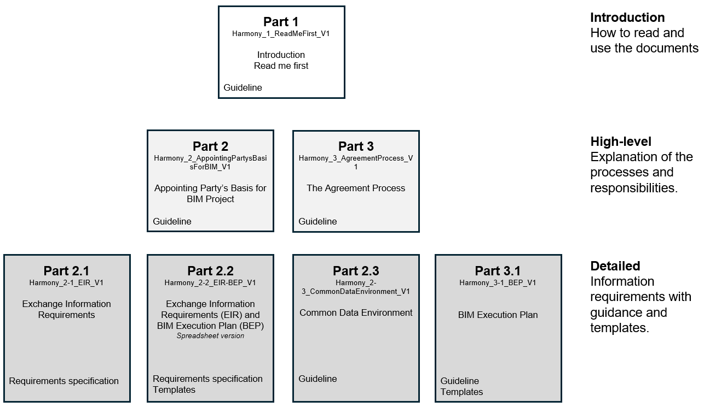
Figure 1 - Document hierarchy and content
The documentation is divided into separate documents. It has a modular structure making it possible to focus on the guidelines you need according to your role and tasks. It is not meant to be read from one end to the other to get the guidelines you need. It is encouraged to read the entire documentation to understand the principles.

3.1 Appointing Party to start a new project

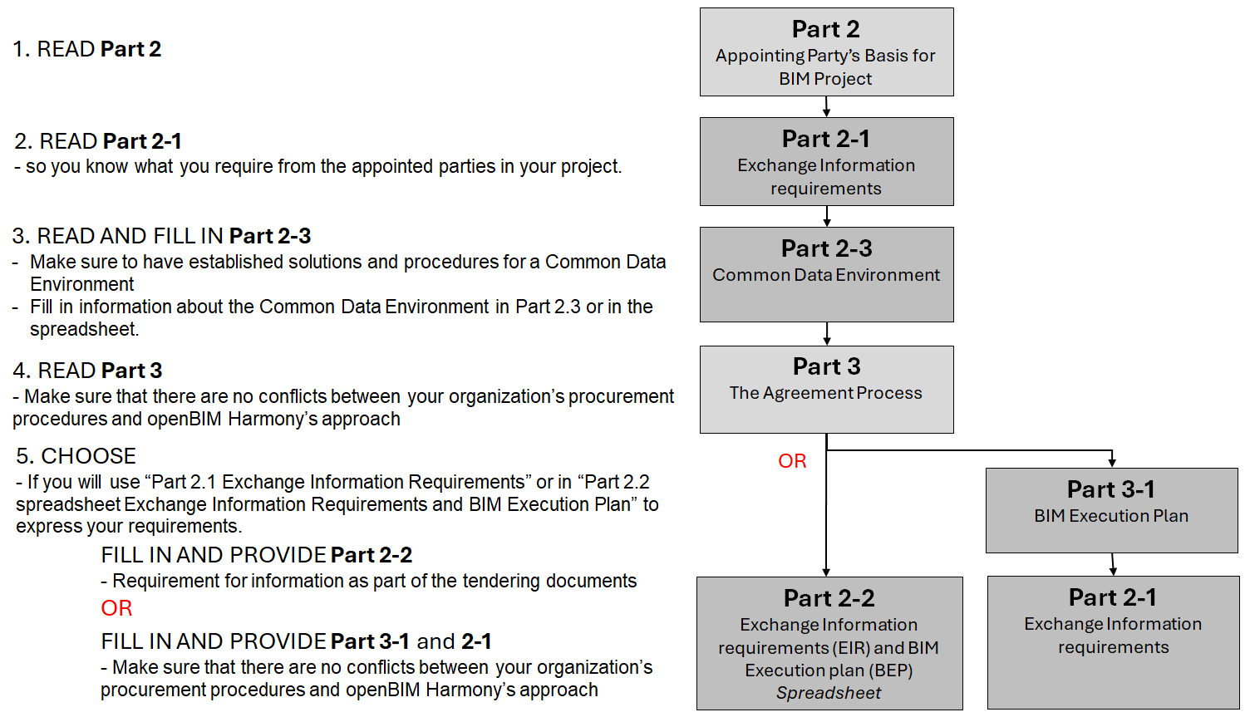

3.2 Potential Lead Appointed offering information delivery services in a project

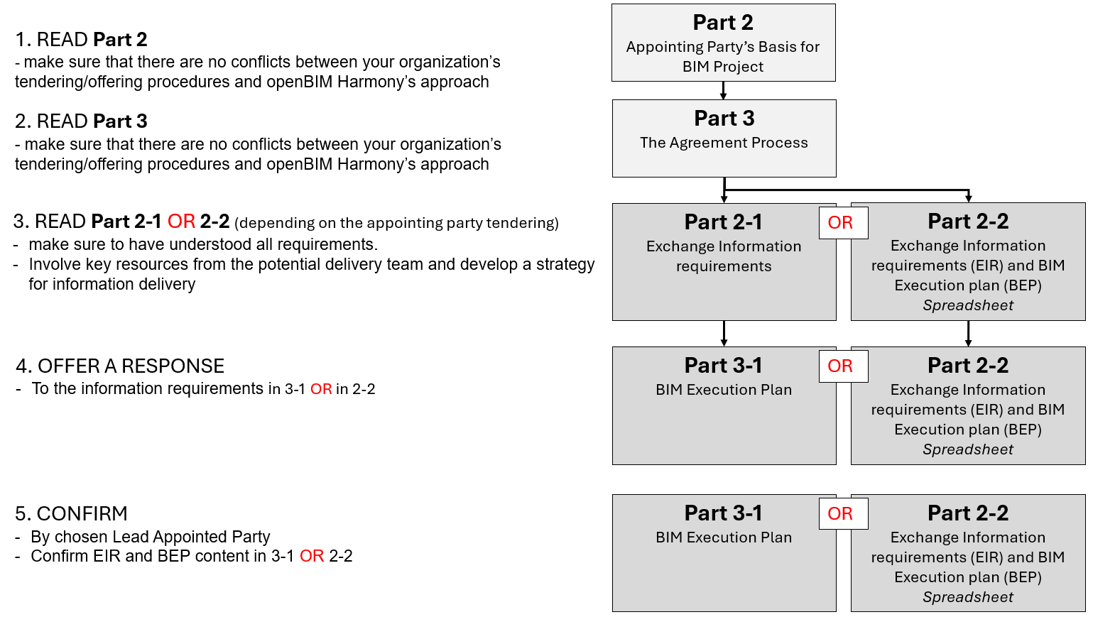

4 Normative standards
Information deliverables and management is based on the following standards.

4.1 EN ISO 19650-1
Organization and digitization of information about construction works, including building information modeling (BIM) - Information management with BIM - Part 1: Concepts and principles
In openBIM Harmony the standard regulates terminology, principles, and Common Data Environment.

4.2 EN ISO 19650-2
Organization and digitization of information on construction works, including building information modeling (BIM) - Information management with BIM — Part 2: The project phase (ISO 19650-2:2018)
In openBIM Harmony the standard regulates establishment and follow-up of governing documents EIR and BEP as well as additional documents in the project phase.

4.3 EN ISO 19650-3
Organization and digitization of information about buildings and civil engineering works, including building information modeling (BIM) - Information management using building information modeling — Part 3: Operational phase of the assets (ISO 19650-3:2020)
In openBIM Harmony the standard regulates organization and follow-up of building information in the operational phase.

4.4 ISO 1787-1
Building information modelling - Level of information need, Part 1: Concepts and principles.
In openBIM Harmony the standard regulates specification of concepts and principles to establish a methodology for specifying level of information need and information deliveries in a consistent way when using building information modelling (BIM).

4.5 CEN/TR 17654
Guidelines for the implementation of Exchange Information Requirements (EIR) and BIM Execution Plans (BEP) at European level based on EN ISO 19650-1 and -2
In openBIM Harmony the standard regulates how requirements for EIR and BEP according to NS-EN ISO 19650 are specified and followed up.

4.6 EN ISO 16739-1
Industry Foundation Classes
In openBIM Harmony the standard regulates how requirements to model information are specified. All requirements are specified in accordance with the IFC standard. The appointed party must translate requirements into its own proprietary software.

4.6 EN-ISO 29481-1, Annex C
Building information models - Information delivery manual - Part 1: Methodology and format
In openBIM Harmony the life-cycle stages in Annex C are used as a generic European common life-cycle reference.

