GUIDELINE

VERSION 1.0
18 March 2025

European openBIM Forum
openBIM Harmony

PART 2.3 COMMON DATA ENVIRONMENT

BUILDINGS

Contents
- Common Data Environment
- Functionality
- Rules for changing the status of information containers
- Checklist requirements for a common data environment
- Naming of information containers
- Recommended metadata for information containers in a common data environment

1 Common Data Environment
This guideline is primarily aimed at appointing parties and owners and those who will support the appointing party in getting the common data environment to work.
A common data environment is a system of one or more solutions that make it possible to exchange information, process issue management and handle information according to agreed use cases. A common data environment is essential for effective information exchange and collaboration.
The client should establish a common data environment from the start of the project so that all actors can work together on the same platform throughout the entire project period. Clients should acquire a common system for a common data environment so that all projects can be serviced and followed up as equally as possible.
The Common data environment is not limited to project implementation. The Common data environment also includes the management of information during the building's lifetime.
Requirements for the functionality of a common data environment in project implementation and management are different and often consist of different solutions. However, the most seamless transfer of information from project to administration should be ensured.
This guideline focuses on a common data environment for the project phase up to and including handover to administration.
This guideline relates to the requirements of EN ISO 19650-1.

2 Functionality
A common data environment is a broad term that can encompass everything from simple exchange of files to a complex system of solutions with many different functionalities that support project start-up, project implementation, transfer to operation and management of information models. This guideline recommends a minimum level of functionality that supports the recommended purposes of BIM as described in Part 2 Appointing Party’s basis for BIM. The minimum recommended functionality for handling models and model information is:
- Exchange of information - It must be possible to exchange information either in the form of files or a model database. Information includes both model information and other information in the information model, including any room and equipment databases, document management, maps and more. Simultaneity in exchange of models
- Manage metadata – It should be possible to get information about information containers. See clause 4 - Recommended Metadata for Information containers in a common data environment
- Version History – Access the latest revision as well as older versions.
- Machine-interpretable requirements format - Read machine-interpretable format for BIM requirements IDS (possibly mvdXML)
- Deviations in models - Finding deviations in models according to requirements for machine-interpretable format.
- Deviation reporting - Report deviations in open BCF format integrated with modeling software for seamless communication with designers. Concurrency in exchange of BCF (API )
- Project dashboard - Report information from models to the project dashboard for management data.

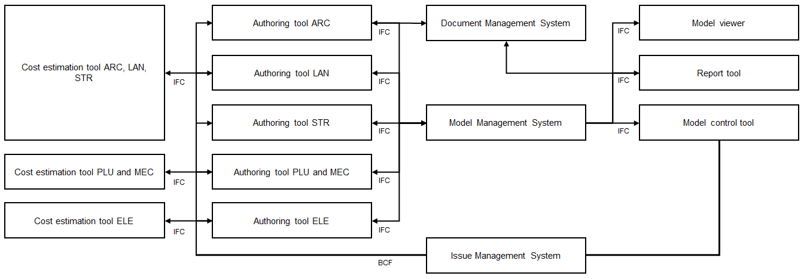
Figure 1 - Schematic concept of a common data environment

This list does not describe the applications of individual subjects or the need for integration into a common data environment, e.g. with plugins or APIs.
Future information exchange will change in the direction to be based to a greater extent on shared databases and exchange with API.

3 Rules for changing the status of information containers

3.1 General
EN ISO 19650 uses the term information containers to describe all types of digital information exchange. It can be files, it can be changes in model server, it can be API search etc. Regardless of how the project exchanges model information, it is relevant to indicate the condition or status of the information.
The ISO standard calls the different levels of information condition. In everyday speech, it is often called status. This should not be mixed with status setting at object level. The different conditions are:
- Work in progress – Typically when a solution is sketched or designed that is not sufficiently mature or quality assured to be shared with the other design disciplines.
- Shared – Typically when a model is shared with other engineering disciplines to be coordinated with their models.
- Published – It can e.g. be that models are interdisciplinary coordinated and quality assured and shared with contractors or subcontractors. Completed does not necessarily mean that the project is finished, but that the subject has come as far as they can.
- Archived – The information has been handed over to information management and satisfies the requirements for these.
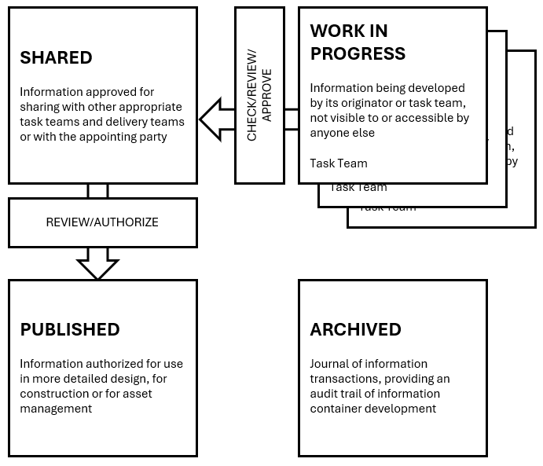
Figure 2 - Different levels of information containers

The following requirements and quality assurance processes ensure that information containers in a common data environment change status in a controlled and documented manner, and meet the necessary standards and quality requirements.
To ensure that information containers (e.g. files, models, documents) in a common data environment change state from "Working" to "Shared", "Published" and "Archived", clear criteria and requirements for quality assurance should be established. Here are the recommended minimum requirements for each state change:

3.2 From "Work in progress" to "Shared"
Quality control
- Discipline approval must be carried out with self-check and peer check to ensure that the information is accurate and consistent.
- Requirements for quality control:
  - The model must represent agreed progress and a basis for decision-making.
  - The model must comply with the requirements for the model at the given time in the project.
  - The file format and structure conform to the defined standards (e.g. IFC, GML, XML)
  - Models must be correctly geolocated and set in the correct coordinate system.
  - Models must be made available in common areas to exchange shared information.

3.3 From "Shared" to "Published"
External verification
- Discipline and cross-disciplinary approval must be carried out with self-check, peer review and interdisciplinary check to ensure that the information is accurate and consistent. Some subjects also require third-party verification.
- Requirements for quality control. In addition to requirements for quality control for "In progress" to "Shared", it applies that:
  - All deviations and corrections of changes from shared phases have been addressed and implemented.
  - Projected material must comply with the Planning and Building Act, local regulations and the project's building programme.
  - Final approval from the project manager or other superior authority.
  - Documentation of the final approval process with necessary signatures or digital confirmations.
  - Save the reports as attachments to the information container.
  - Models must be made available in common areas for senders and receivers of completed information.

3.4 To "Archived"
Completeness check
- Discipline approval must be carried out with a self-check and a peer check that confirms that the information container is complete and that all necessary data and documents, including the current version of the EIR and BEP, are included.
- Requirements for quality control:
  - Check that there have been no changes to the information since the last approval.
  - Models must be cleaned for:
    - Drafts, copies and alternative solutions
    - External references
  - Proprietary models must be able to be opened in the same version as without the use of special third-party software, plug-ins and add-ons.
- Ensure that any associated documents or references are correct and accessible.
- Ensure that all required metadata is provided and correct.
- Add relevant archive metadata for future reference.
- Implement the information management archiving process that includes transferring the information container to a secure, long-term storage medium.
- Adjust access rights to limit changes and access to authorized people only. Ensure that archived data is protected against unauthorized access and changes.

4 Checklist requirements for a common data environment
This checklist will ensure that the common data environment implemented in the project is in line with best practice and standards and ensures efficient data handling, communication and security throughout the project's life cycle.
4.1 Availability and user access
  - Ability to manage users, assign and revoke access rights.
  - Control over who has access to specific data, files and information.
  - Defined roles and responsibilities with customized access levels.
  - Secure methods of authentication (eg two-factor authentication).
4.2 Data security
  - The data must be securely stored and be able to be restored in the event of loss.
  - Data must be encrypted both during transmission and during storage.
  - Regular backups and a clear data recovery plan.
  - Logging of all activities (who has done what and when).
4.3 Compliance with the project's information standard and requirements for a common data environment
  - Support for standardized metadata, file naming conventions, and classification systems.
  - Built-in processes for reviewing, approving and sharing documents according to the four states (work in progress, shared, published, archived).
  - Checking that information delivered to the project complies with the requirements specifications.
4.4 Document management and version control
  - The system must support version control to keep track of changes to files and documents.
  - Ability to track revisions and changes over time as well as access previous versions of information containers.
  - Users should be notified of changes to documents or project information.
  - Easy to share documents with the right recipients in the project.
4.5 Cooperation and communication
  - The system must support real-time editing or shared documents for seamless collaboration.
  - Built-in tools for commenting, tagging and giving feedback on files.
  - Messaging system that enables project groups to communicate directly in a common data environment.
4.6 Integration and compatibility
  - The system must be able to be integrated with other BIM tools and support open formats such as IFC.
  - Possibility of integration with external systems and software via APIs.
  - Cross-platform compatibility. Information management must work on different devices (PC, tablet, mobile) and browsers.
4.7 User training and support
  - User manual, tutorials and FAQs available.
  - The system should have customer support available for questions and technical problems.
  - User training with an offer of training resources or courses for effective use of a common data environment.
4.8 Performance and scalability
  - The system must be able to handle large amounts of data efficiently without significant delays.
  - The common data environment must be scalable to adapt to both small and large projects.
4.9 Compliance with laws and regulations
  - The common data environment must comply with the requirements for privacy and data security according to GDPR and other relevant laws.
  - The system must support national standards, e.g. NS 8360 in Norway.
4.10 Updates and maintenance
  - The system should be updated with security and functional improvements regularly.
  - The common data environment must be stable and have minimal downtime, with planned maintenance well announced.

5 Naming of information containers

5.1 Generally
It is recommended to use a standardized naming convention to contribute to better organization, easier retrieval of files and reduced risk of confusion and errors in construction projects. The following proposal is primarily meant for countries/projects without an established standard for file naming.

5.2 Syntax
Many appointing parties have their own information container name requirements. This framework recommends the following syntax for clients/projects that does not have such established naming conventions:
Bold text = Mandatory
Italic text = Voluntarily

5.2.1 Project stage
In the project phase, it is not desirable to have the project number in the file name. Project name is only provided as metadata. The project name does not provide much value in the file name since all documents start with the same name. In some user interfaces, such as mobile applications it can be a problem that you only see the project name on all files.

Syntax project stage:
[Building/Construction code]_[Construction subdivision code]_[Discipline code]_[Building element classification]_[Document type]_[Building Storey]_[Zone]_[Serial number]

Example: 12345_A_ARC_230_110_03_XX_XXX (X means no value in the field)

5.2.2 Facility Management stage
Facility Managers who have more than one building to manage should add the property number to the file name to be able to distinguish between different properties.

Syntax Facility Management stage:
[Property code]_[Building/Construction code]_[Construction subdivision code]_[ [Discipline code]_[Building element classification]_[Document type]_[Building Storey]_[Zone]_[Serial number]

123456_12345_A_ARC_230_110_03_XX_XXX (X means no value in the field)

5.3 Revision and date as metadata
Information about e.g. version/revision and date shall only be handled as metadata. This is done because, in a common data environment, files are often linked to each other and/or various processes have been automated based on information container names. If models change names for each new revision, this must be set up again for each change.

5.4 The filename components

5.4.1 Project name and property name
Project number is only provided as metadata. Project number is provided by the appointing party.
When using property name in the facility management. The property code is provided by the building owner.

5.4.2 Building/Construction code
A short code that identifies which building or area the model belongs to.
Example: B1 [=Building 1], A2 [Area 2].

5.4.3 Discipline code
A short code for the discipline to which the model belongs. It is recommended to use subject codes standardized at national level for a common understanding of these.

5.4.4 Building element
Indication of building element according to National classification.

5.4.5 Document type
Enter code for document type according to National classification.

5.4.6 Building story
If relevant for the building/construction. Use the code for the building storey according to National classification.

5.4.7 Zone
Enter code for zone. Codes are established by project.

5.4.8 Serial number
If there are several models in the project from the same subject and with the same type of content or subdivision, it may be appropriate to use serial numbers. This component is only used if there is a need to distinguish between several information containers from the same subject with the same content/subdivision.

5.5 Implementation and maintenance
- Specify guidelines that describe the naming convention in detail and distribute this to all project participants.
- Ensure training of all relevant resources so that they understand and follow the naming convention.
- Establish a system to check and approve file names before they are uploaded to the common data environment.
- Consider using software or scripts to automate the naming process where possible.

6 Recommended metadata for information containers in a common data environment

6.1 General
Metadata is essential to ensure that information containers are managed efficiently in a common data environment. They provide the necessary context, tracking and control over the information containers, enabling all parties involved to access the right information at the right time. This is crucial for achieving optimal interaction and project management.

6.2 General metadata
- Filename - Unique name of the information container.
- File Type - Format of the information container (e.g. IFC, RVT, DNG, DWG).
- File Size - The size of the file in megabytes (MB).
- Version - Version number or code to track changes.
- Creation Date - Date and time when the file was created.
- Last modification - Date and time of last modification.

6.3 Project-specific metadata
- Project name - Name of the project the file belongs to.
- Project number - Unique number that identifies the project.
- Client - Name of client.
- Appointed party - Name of the appointed party who is responsible for delivering the model.
- Project phase – Phase or main milestone to which the delivery applies.

6.4 BIM-specific metadata
- Model Name - Name of the specific model.
- Subject area - Subject discipline to which the model belongs (e.g. ARC, LAN, STR, PLU, MEC, ELE).
- Author - Name of the person or team who created or edited the model.
- Approved by - Name of the person who has approved the model.
- Status - Status of the model (Work in progress, Shared, Published and Archived).

6.5 Geographic metadata
- Coordination Reference System – Coordination reference system used in the model (e.g. EPSG:4326).
- Geolocation - GPS coordinates for the model's location.

6.6 Document handling metadata
- Document type - Type of document (e.g. drawing, report, model).
- Reference number - Unique number that identifies the document.
- Revision - Revision number or code for the document.
- Distribution list - List of people or entities that have received the document.

6.7 Security and Access metadata
- Access Level - What level of access is required to view or edit the file.
- Ownership - Name of the person or team that owns the file.
- Confidentiality Level - Level of confidentiality (e.g. public, internal, confidential).

6.8 Technical metadata
- Software - Software used to create or edit the file (e.g. Revit, ArchiCAD, Tekla).
- Software version - Version of the software used.
- File structure - Information about the file's internal structure, if relevant.

6.9 Metadata integration
- Links - Any links to other relevant documents or models.
- Relationships - Relationships to other information containers or project data.

