GUIDELINE

VERSION 1.0
18 March 2025

European openBIM Forum
openBIM Harmony

PART 3 – THE AGREEMENT PROCESS

GENERAL

Contents
Agreement on deliveries for and use of the model
- The Agreement Process
- Weighting response to Information Exchange Requirements (EIR)

The agreement process

General
This part provides guidance on how to agree what is to be delivered and how the models are to be used between the appointing party and the lead appointed party.

The overall process
The agreement process has three overall steps:
- The invitation to tender where the information delivery is specified in the exchange information requirements (EIR)
- The tender response by the potential lead appointed parties. Their response to the exchange information requirements ideally by describing approach and goals for the information delivery in the pre-appointment BIM execution plan (BEP) clauses 2 and 3.
- After the lead appointed party is chosen, they confirm their BIM execution plan.

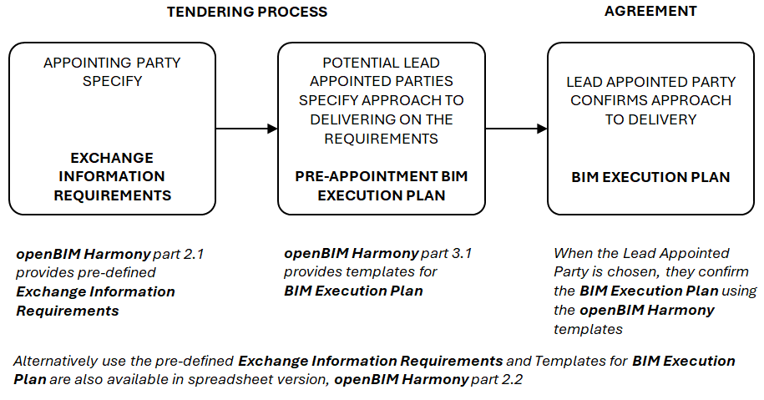
Figure 1 – The three overall steps of the agreement process

Weighting of response to Exchange Information Requirements (EIR)
The potential lead appointed parties’ approach to delivering on the requirements can be weighed differently as part of the evaluation. If the appointing party has subcontracted a consultant to develop the EIR, the consultant should be involved in the evaluation of the pre-appointment BIM Execution Plan.
Some responses may suggest different deliverables. Unless otherwise agreed the requirements in the appointing party’s exchange information requirements applies regardless of the tender response.
When evaluating the tender responses there are different ways to weigh the responses.

Qualification requirements
The requirement is absolute and if the tender response does not satisfy the requirements the potential lead appointing party disqualified. This approach can be chosen if the requirement is perceived as a condition for the project's successful execution.

Evaluation criteria
The response to the EIR is given points as part of a total score also considering e.g. cost. understanding of the delivery, resources offered etc. This approach can be chosen if the lead appointed party's ability to deliver on the requirement is an important part of the project.

Task understanding
The response is not given separate points. The response is assessed as a part of the potential lead appointed party’s overall understanding of the delivery. This approach is appropriate if the lead appointed party’s ability to deliver according to the EIR is important, but the appointing party has little experience in requiring BIM.

